Case Study Shows Feasibility of Stem Cell Treatment after Liver Organ Transplant
August 6, 2015 | Mesenchymal Stem Cells
Review of “First-in-Human Case Study: Multipotent Adult Progenitor Cells for Immunomodulation after Liver Transplantation” from Stem Cells Translational Medicine by Stuart P.
Patients undergoing organ transplants usually face unwanted side effects due to the need for long-term pharmacological immunosuppression to inhibit organ rejection, and so, much research has gone into devising alternative tolerance strategies. Mesenchymal stem cells [1] and multipotent adult progenitor cells (MAPCs) [2] are known for their ability to dampen immune responses and this led to the publication of preclinical studies from the laboratory of Marc H. Dahlke (University Hospital Regensburg, Germany), the 2014 Stem Cells Translational Medicine Young Investigator Award Winner [3], and others [4], showing that these cell types can indeed prolong allogeneic solid organ transplant survival. These studies have now led to the MiSOT-I (Mesenchymal Stem Cells in Solid Organ Transplantation Phase I) trial [5, 6], and a clinical case report published recently in Stem Cells Translational Medicine [7].
The patient of interest, a 27-year-old male with liver cirrhosis of unknown etiology, received 1.5 x 10⁸ commercially available MAPCs (Multi-Stem - Athersys Inc.) via injection into the portal vein (day 0) after receiving a living-related adult right liver graft from his brother, and on day 2 (intravenously). Encouragingly, there was no evidence of thrombosis, stenosis, or other harmful side effects, and indeed, the study found no severe treatment-emergent adverse events linked to the infusion of the cells. The patient did suffer acute rejection episodes at 5 days and 6 months after transplant with both episodes successfully managed with immunosuppressant drug (cyclosporine and methylprednisolone) treatment. Apart from these two brief episodes, the patient presented with normal liver function and normal leukocyte counts, suggesting a successful liver transplant in the presence of MAPCs.
Liver biopsy samples obtained before reperfusion and shortly after cell infusion demonstrated that MAPCs were present in the liver parenchyma, as shown by the presence of HLAA*03 (red staining in Figure E-H), an HLA class I allele expressed by the infused MAPC product, but not by donor and recipient cells. With regards to the immune response to the transplantation and MAPC infusion, the data gathered demonstrated possible diminished immunological reactivity, although confirming this finding will require further extended studies.
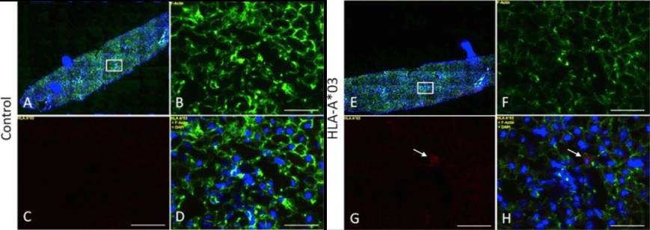
This first-in-human case demonstrates that MAPC transplantation after liver transplantation is feasible and safe within the time frame studied and may represent and exciting new method of dampening immune responses after organ transplants. The authors note that the recruitment and follow-up of participants in the MiSOT-I trial continues, and they hope to complete the study in the autumn of 2016. Stay tuned for an update on this potentially important treatment strategy.
References
- Dominici M, Le Blanc K, Mueller I, et al. Minimal criteria for defining multipotent mesenchymal stromal cells. The International Society for Cellular Therapy position statement. Cytotherapy 2006;8:315-317.
- Reyes M and Verfaillie CM Characterization of multipotent adult progenitor cells, a subpopulation of mesenchymal stem cells. Annals of the New York Academy of Sciences 2001;938:231-233; discussion 233-235.
- Eggenhofer E, Popp FC, Mendicino M, et al. Heart grafts tolerized through third-party multipotent adult progenitor cells can be retransplanted to secondary hosts with no immunosuppression. Stem Cells Translational Medicine 2013;2:595-606.
- Casiraghi F, Azzollini N, Cassis P, et al. Pretransplant infusion of mesenchymal stem cells prolongs the survival of a semiallogeneic heart transplant through the generation of regulatory T cells. Journal of immunology 2008;181:3933-3946.
- Dillmann J, Popp FC, Fillenberg B, et al. Treatment-emergent adverse events after infusion of adherent stem cells: the MiSOT-I score for solid organ transplantation. Trials 2012;13:211.
- Popp FC, Fillenberg B, Eggenhofer E, et al. Safety and feasibility of third-party multipotent adult progenitor cells for immunomodulation therapy after liver transplantation--a phase I study (MISOT-I). Journal of translational medicine 2011;9:124.
- Soeder Y, Loss M, Johnson CL, et al. First-in-Human Case Study: Multipotent Adult Progenitor Cells for Immunomodulation After Liver Transplantation. Stem Cells Transl Med 2015;4:899-904.

